Eanjia Bubble Balloon Use Instruction

Bubble balloon introduce

Eanjia bubble balloon is made by TPU material, it’s strong, flexible film, high abrasion, wear, oil resistance. Safe Non-toxic; Biodegradable.

Its material are totally different with Qualatex bubble balloons.

Note:

TPU bubble balloon is affect by temperature when use air blow up.

We suggest that use electric pump inflation bubble balloon please blow up under temperature less 30℃/86℉.

It's better to inflate it indoors than outdoors.

Filling helium not affected by temperature.

Recommended tools

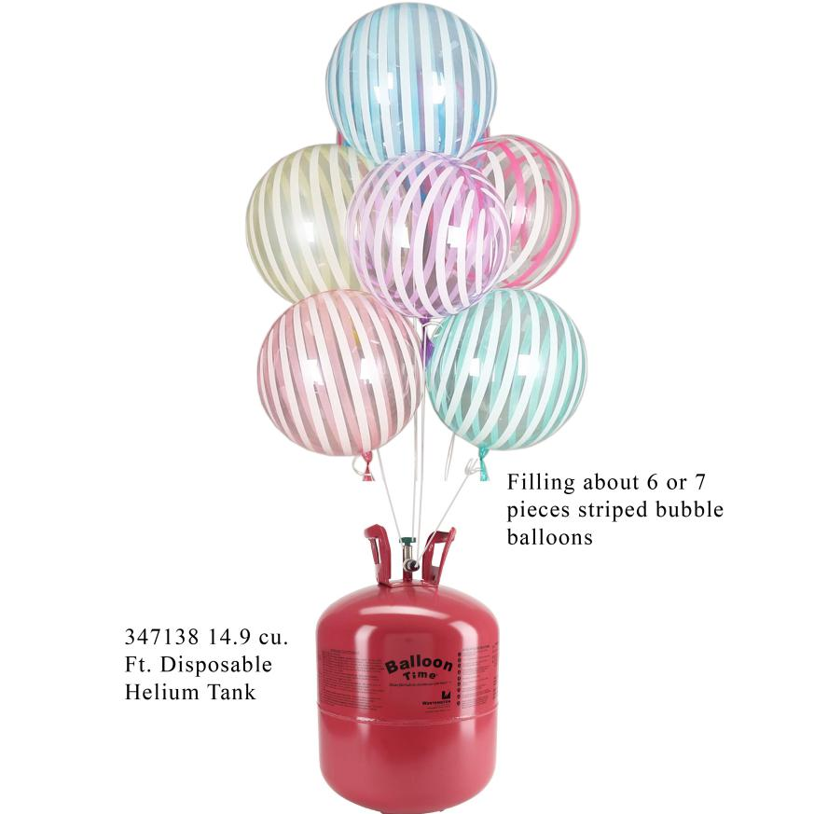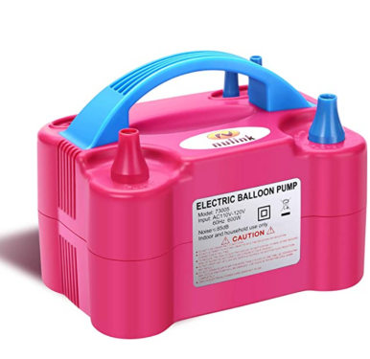

# Need video tutorials ?

Please search this title on Youtube

# New Macaroon Color Bubble Balloons Review + GIVEAWAY ( CLOSED)

[Anastasia Onishchenko](https://www.youtube.com/channel/UClUo2PYXG5sPHwshQMTxXlw)

1. Size information

|  |  |  |
| --- | --- | --- |
| Balloon Size | Suggestion size | Max blow up size |
| 10inch | 10inch/25cm | 12inch/30cm |
| 16inch | 14inch/35cm | 16inch/40cm |
| 18inch | 14inch to 16inch  35cm to 40cm | 18inch  45cm |
| 20inch | 18inch/45cm | 24inch /60cm |
| 24inch | 20inch/50cm | 24inch/60cm |
| 30inch | 28inch/70cm | 30inch/75cm |
| 36inch | 32inch /80cm | 36inch /90cm |

----------------------**Some decorations we work with decorators** ---------------------------

* **Ceiling Balloon Garland, bubble balloons by Eanjia 18’’ stripe bubble**

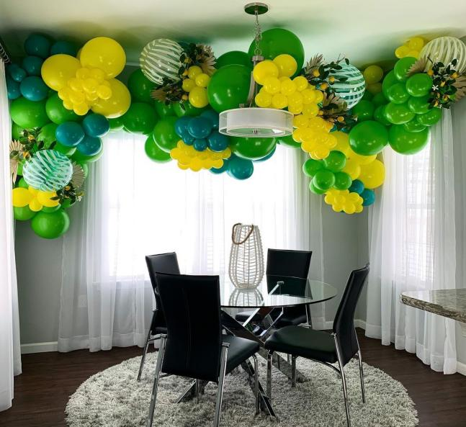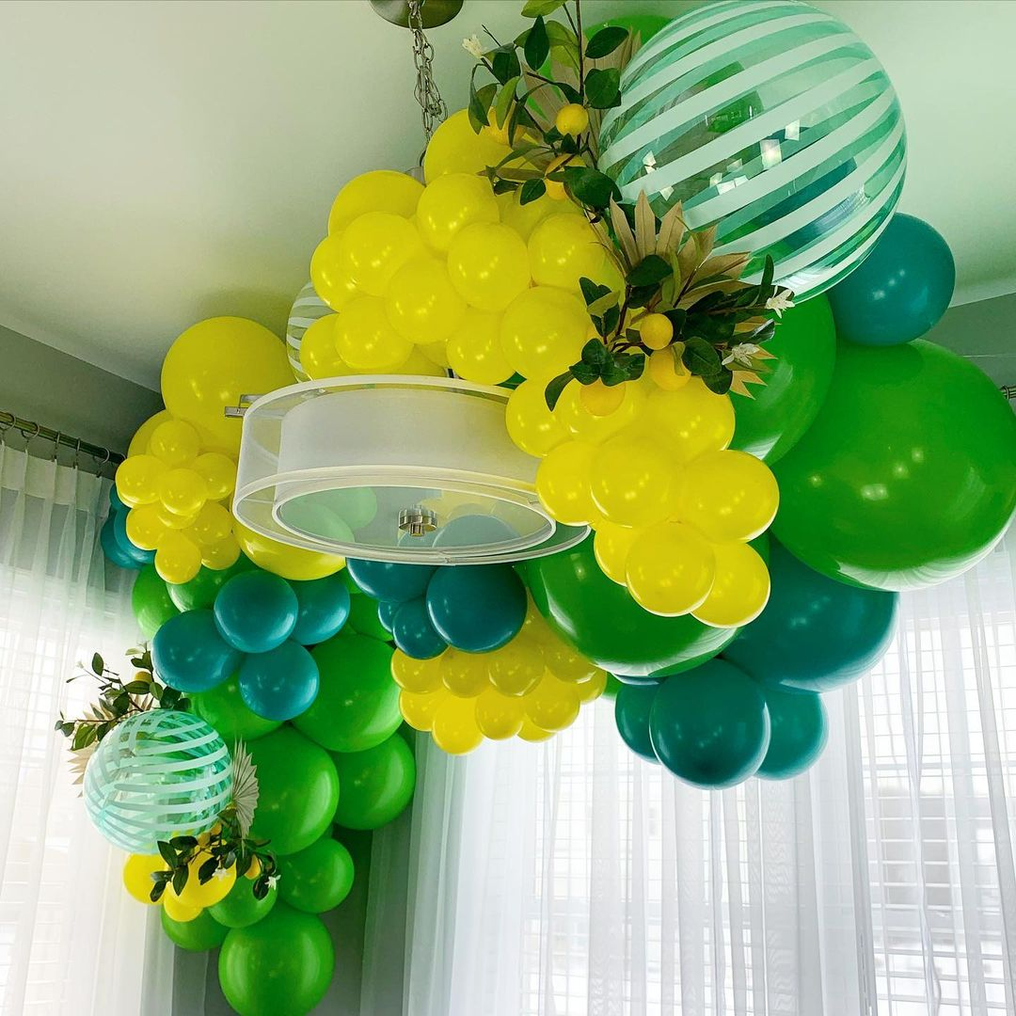

Complete tutorial on Youtube: <https://www.youtube.com/watch?v=Kptv0bQOeak&t=1022s>

* **Gender Reveal Balloon Decoration, bubble balloons by Eanjia 18’’ baby feet bubble.**

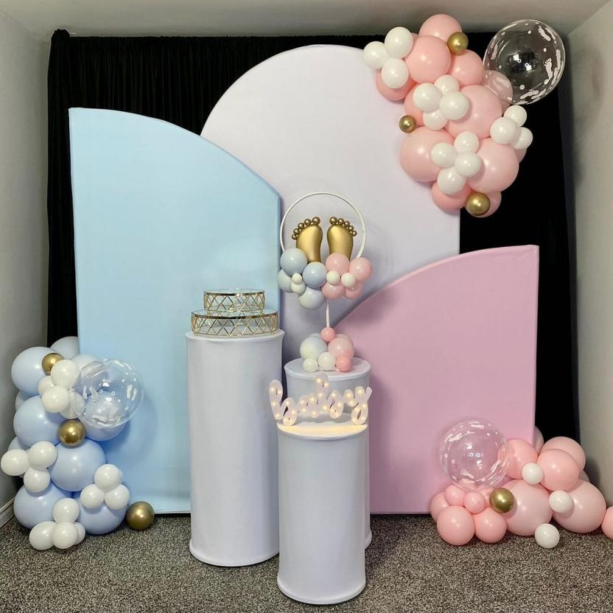

Complete tutorial on Youtube: <https://www.youtube.com/watch?v=Yb2GVabP0mc>

* **Rose Inside Bubble Balloon, by Eanjia 18’’ confetti bubble balloons**

